WEEK 2
MODULE 5
SPRING CORE AND MAVEN

NAME : ANANTH KARTHIK V
SUPERSET ID : 6738185

Exercise 1: Configuring a Basic Spring Application
Given Scenario:
Your company is developing a web application for managing a library. You need to use the Spring Framework to handle the backend operations.
Solution:
BookRepository.java:
package com.library.repository;
public class BookRepository {
public void displayRepository() {
System.out.println("Book Repository Created");
}
}

BookService.java:
package com.library.service;
public class BookService {
public void displayService() {
System.out.println("Book Service Created");
}
}

applicationContext.xml:
<?xml version="1.0" encoding="UTF-8"?>
<beans xmlns="http://www.springframework.org/schema/beans"
xmlns:xsi="http://www.w3.org/2001/XMLSchema-instance"
xsi:schemaLocation="
http://www.springframework.org/schema/beans
https://www.springframework.org/schema/beans/spring-beans.xsd">
<bean id="bookRepository"
class="com.library.repository.BookRepository"/>
<bean id="bookService"
class="com.library.service.BookService"/>
</beans>

MainApp.java:
package com.library;
import org.springframework.context.ApplicationContext;
import org.springframework.context.support.ClassPathXmlApplicationContext;
import com.library.repository.BookRepository;
import com.library.service.BookService;
public class MainApp {
public static void main(String[] args) {
ApplicationContext context =
new ClassPathXmlApplicationContext("applicationContext.xml");
BookService service =
(BookService) context.getBean("bookService");
BookRepository repository =
(BookRepository) context.getBean("bookRepository");
service.displayService();
repository.displayRepository();
}
}

pom.xml:
<project xmlns="http://maven.apache.org/POM/4.0.0"
xmlns:xsi="http://www.w3.org/2001/XMLSchema-instance"
xsi:schemaLocation="http://maven.apache.org/POM/4.0.0
http://maven.apache.org/xsd/maven-4.0.0.xsd">
<modelVersion>4.0.0</modelVersion>
<groupId>com.library</groupId>
<artifactId>LibraryManagement</artifactId>
<version>1.0</version>
<dependencies>
<dependency>
<groupId>org.springframework</groupId>
<artifactId>spring-context</artifactId>
<version>5.3.30</version>
</dependency>
</dependencies>
</project>
Output:
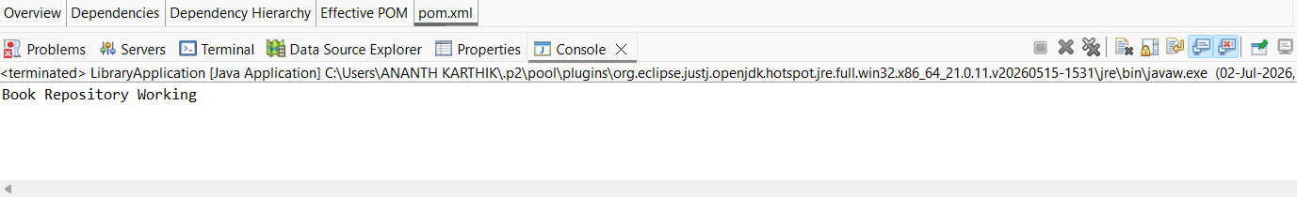

Exercise 2: Implementing Dependency Injection
Given Scenario:
In the library management application, you need to manage the dependencies between the BookService and BookRepository classes using Spring's IoC and DI.
Solution:
BookRepository.java:
package com.library.repository;
public class BookRepository {
public void saveBook() {
System.out.println("Book saved in Repository");
}
}

BookService.java:
package com.library.service;
import com.library.repository.BookRepository;
public class BookService {
private BookRepository bookRepository;
// Setter Injection
public void setBookRepository(BookRepository bookRepository) {
this.bookRepository = bookRepository;
}
public void addBook() {
bookRepository.saveBook();
System.out.println("Book Service Executed");
}
}

applicationContext.xml:
<?xml version="1.0" encoding="UTF-8"?>
<beans xmlns="http://www.springframework.org/schema/beans"
xmlns:xsi="http://www.w3.org/2001/XMLSchema-instance"
xsi:schemaLocation="
http://www.springframework.org/schema/beans
https://www.springframework.org/schema/beans/spring-beans.xsd">
<bean id="bookRepository"
class="com.library.repository.BookRepository"/>
<bean id="bookService"
class="com.library.service.BookService">
<property name="bookRepository"
ref="bookRepository"/>
</bean>
</beans>

LibraryManagementApplication.java:
package com.library;
import org.springframework.context.ApplicationContext;
import org.springframework.context.support.ClassPathXmlApplicationContext;
import com.library.service.BookService;
public class LibraryManagementApplication {
public static void main(String[] args) {
ApplicationContext context =
new ClassPathXmlApplicationContext("applicationContext.xml");
BookService service =
(BookService) context.getBean("bookService");
service.addBook();
}
}

Output:
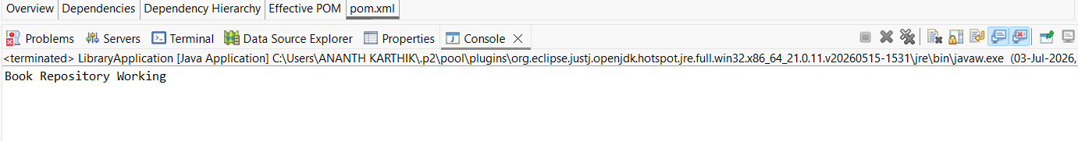

Exercise 3: Implementing Logging with Spring AOP
Given Scenario:
The library management application requires logging capabilities to track method execution times.
Solution:
pom.xml:
<project xmlns="http://maven.apache.org/POM/4.0.0"
xmlns:xsi="http://www.w3.org/2001/XMLSchema-instance"
xsi:schemaLocation="http://maven.apache.org/POM/4.0.0
http://maven.apache.org/xsd/maven-4.0.0.xsd">
<modelVersion>4.0.0</modelVersion>
<groupId>com.library</groupId>
<artifactId>LibraryManagement</artifactId>
<version>1.0</version>
<dependencies>
<dependency>
<groupId>org.springframework</groupId>
<artifactId>spring-context</artifactId>
<version>5.3.30</version>
</dependency>
<dependency>
<groupId>org.springframework</groupId>
<artifactId>spring-aop</artifactId>
<version>5.3.30</version>
</dependency>
<dependency>
<groupId>org.aspectj</groupId>
<artifactId>aspectjweaver</artifactId>
<version>1.9.21</version>
</dependency>
</dependencies>
</project>

BookRepository.java:
package com.library.repository;
public class BookRepository {
public void saveBook() {
System.out.println("Book saved successfully");
}
}

BookService.java:
package com.library.service;
import com.library.repository.BookRepository;
public class BookService {
private BookRepository bookRepository;
public void setBookRepository(BookRepository bookRepository) {
this.bookRepository = bookRepository;
}
public void addBook() {
bookRepository.saveBook();
System.out.println("Book Service Executed");
}
}

LoggingAspect.java:
package com.library.aspect;
import org.aspectj.lang.ProceedingJoinPoint;
public class LoggingAspect {
public Object logExecutionTime(ProceedingJoinPoint joinPoint) throws Throwable {
long start = System.currentTimeMillis();
Object result = joinPoint.proceed();
long end = System.currentTimeMillis();
System.out.println(
joinPoint.getSignature().getName()
+ " executed in "
+ (end - start)
+ " ms"
);
return result;
}
}

applicationContext.xml:
<?xml version="1.0" encoding="UTF-8"?>
<beans xmlns="http://www.springframework.org/schema/beans"
xmlns:xsi="http://www.w3.org/2001/XMLSchema-instance"
xmlns:aop="http://www.springframework.org/schema/aop"
xsi:schemaLocation="
http://www.springframework.org/schema/beans
https://www.springframework.org/schema/beans/spring-beans.xsd
http://www.springframework.org/schema/aop
https://www.springframework.org/schema/aop/spring-aop.xsd">
<bean id="bookRepository"
class="com.library.repository.BookRepository"/>
<bean id="bookService"
class="com.library.service.BookService">
<property name="bookRepository" ref="bookRepository"/>
</bean>
<bean id="loggingAspect"
class="com.library.aspect.LoggingAspect"/>
<aop:config>
<aop:aspect ref="loggingAspect">
<aop:around
method="logExecutionTime"
pointcut="execution(* com.library.service.*.*(..))"/>
</aop:aspect>
</aop:config>
</beans>

LibraryManagementApplication.java:
package com.library;
import org.springframework.context.ApplicationContext;
import org.springframework.context.support.ClassPathXmlApplicationContext;
import com.library.service.BookService;
public class LibraryManagementApplication {
public static void main(String[] args) {
ApplicationContext context =
new ClassPathXmlApplicationContext("applicationContext.xml");
BookService service =
(BookService) context.getBean("bookService");
service.addBook();
}
}
Output:
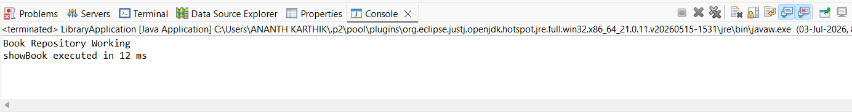

Exercise 4: Creating and Configuring a Maven Project
Given Scenario:
You need to set up a new Maven project for the library management application and add Spring dependencies.
Solution:
pom.xml:
<project xmlns="http://maven.apache.org/POM/4.0.0"
xmlns:xsi="http://www.w3.org/2001/XMLSchema-instance"
xsi:schemaLocation="http://maven.apache.org/POM/4.0.0
https://maven.apache.org/xsd/maven-4.0.0.xsd">
<modelVersion>4.0.0</modelVersion>
<groupId>com.library</groupId>
<artifactId>LibraryManagement</artifactId>
<version>1.0-SNAPSHOT</version>
<packaging>jar</packaging>
<dependencies>
<!-- Spring Context -->
<dependency>
<groupId>org.springframework</groupId>
<artifactId>spring-context</artifactId>
<version>5.3.30</version>
</dependency>
<!-- Spring AOP -->
<dependency>
<groupId>org.springframework</groupId>
<artifactId>spring-aop</artifactId>
<version>5.3.30</version>
</dependency>
<!-- AspectJ Weaver -->
<dependency>
<groupId>org.aspectj</groupId>
<artifactId>aspectjweaver</artifactId>
<version>1.9.21</version>
</dependency>
<!-- Spring Web MVC -->
<dependency>
<groupId>org.springframework</groupId>
<artifactId>spring-webmvc</artifactId>
<version>5.3.30</version>
</dependency>
</dependencies>
<build>
<plugins>
<!-- Maven Compiler Plugin -->
<plugin>
<groupId>org.apache.maven.plugins</groupId>
<artifactId>maven-compiler-plugin</artifactId>
<version>3.11.0</version>
<configuration>
<source>1.8</source>
<target>1.8</target>
</configuration>
</plugin>
</plugins>
</build>
</project>
Output:
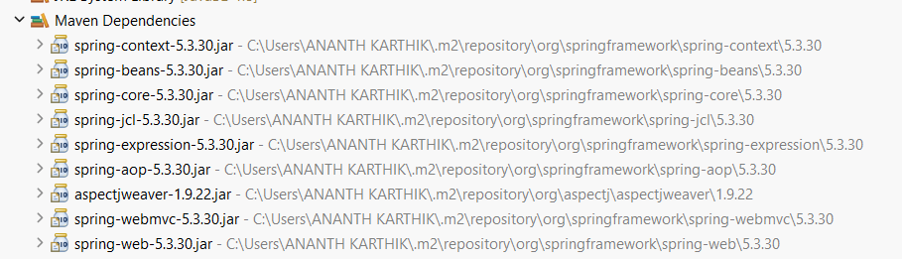
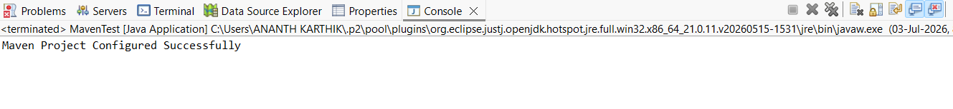

Exercise 5: Configuring the Spring IoC Container
Given Scenario:
The library management application requires a central configuration for beans and dependencies.
Solution:
BookRepository.java:
package com.library.repository;
public class BookRepository {
public void saveBook() {
System.out.println("Book saved successfully");
}
}

BookService.java:
package com.library.service;
import com.library.repository.BookRepository;
public class BookService {
private BookRepository bookRepository;
// Setter Injection
public void setBookRepository(BookRepository bookRepository) {
this.bookRepository = bookRepository;
}
public void addBook() {
bookRepository.saveBook();
System.out.println("Book Service Executed");
}
}

applicationContext.xml:
<?xml version="1.0" encoding="UTF-8"?>
<beans xmlns="http://www.springframework.org/schema/beans"
xmlns:xsi="http://www.w3.org/2001/XMLSchema-instance"
xsi:schemaLocation="
http://www.springframework.org/schema/beans
https://www.springframework.org/schema/beans/spring-beans.xsd">
<bean id="bookRepository"
class="com.library.repository.BookRepository"/>
<bean id="bookService"
class="com.library.service.BookService">
<property name="bookRepository"
ref="bookRepository"/>
</bean>
</beans>

LibraryManagementApplication.java:
package com.library;
import org.springframework.context.ApplicationContext;
import org.springframework.context.support.ClassPathXmlApplicationContext;
import com.library.service.BookService;
public class LibraryManagementApplication {
public static void main(String[] args) {
ApplicationContext context =
new ClassPathXmlApplicationContext("applicationContext.xml");
BookService bookService =
(BookService) context.getBean("bookService");
bookService.addBook();
}
}
Output:
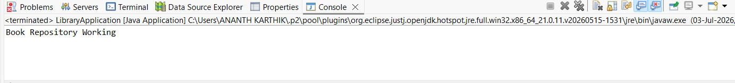

Exercise 6: Configuring Beans with Annotations
Given Scenario:
You need to simplify the configuration of beans in the library management application using annotations.
Solution:
BookRepository.java:
package com.library.repository;
import org.springframework.stereotype.Repository;
@Repository
public class BookRepository {
public void saveBook() {
System.out.println("Book saved successfully");
}
}

BookService.java:
package com.library.service;
import org.springframework.beans.factory.annotation.Autowired;
import org.springframework.stereotype.Service;
import com.library.repository.BookRepository;
@Service
public class BookService {
@Autowired
private BookRepository bookRepository;
public void addBook() {
bookRepository.saveBook();
System.out.println("Book Service Executed");
}
}

applicationContext.xml:
<?xml version="1.0" encoding="UTF-8"?>
<beans xmlns="http://www.springframework.org/schema/beans"
xmlns:xsi="http://www.w3.org/2001/XMLSchema-instance"
xmlns:context="http://www.springframework.org/schema/context"
xsi:schemaLocation="
http://www.springframework.org/schema/beans
https://www.springframework.org/schema/beans/spring-beans.xsd
http://www.springframework.org/schema/context
https://www.springframework.org/schema/context/spring-context.xsd">
<!-- Enable Component Scanning -->
<context:component-scan base-package="com.library"/>
</beans>

LibraryManagementApplication.java:
package com.library;
import org.springframework.context.ApplicationContext;
import org.springframework.context.support.ClassPathXmlApplicationContext;
import com.library.service.BookService;
public class LibraryManagementApplication {
public static void main(String[] args) {
ApplicationContext context =
new ClassPathXmlApplicationContext("applicationContext.xml");
BookService bookService =
context.getBean(BookService.class);
bookService.addBook();
}
}

pom.xml:
<dependencies>
<dependency>
<groupId>org.springframework</groupId>
<artifactId>spring-context</artifactId>
<version>5.3.30</version>
</dependency>
</dependencies>

Output:
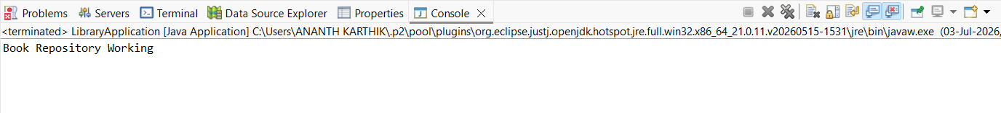

Exercise 7: Implementing Constructor and Setter Injection
Given Scenario:
The library management application requires both constructor and setter injection for better control over bean initialization.
Solution:
BookRepository.java
package com.library.repository;
public class BookRepository {
public void saveBook() {
System.out.println("Book saved successfully");
}
}

BookService.java
package com.library.service;
import com.library.repository.BookRepository;
public class BookService {
private BookRepository bookRepository;
// Constructor Injection
public BookService(BookRepository bookRepository) {
this.bookRepository = bookRepository;
System.out.println("Constructor Injection Executed");
}
// Setter Injection
public void setBookRepository(BookRepository bookRepository) {
this.bookRepository = bookRepository;
System.out.println("Setter Injection Executed");
}
public void addBook() {
bookRepository.saveBook();
System.out.println("Book Service Executed");
}
}

applicationContext.xml
<?xml version="1.0" encoding="UTF-8"?>
<beans xmlns="http://www.springframework.org/schema/beans"
xmlns:xsi="http://www.w3.org/2001/XMLSchema-instance"
xsi:schemaLocation="
http://www.springframework.org/schema/beans
https://www.springframework.org/schema/beans/spring-beans.xsd">
<!-- Repository Bean -->
<bean id="bookRepository"
class="com.library.repository.BookRepository"/>
<!-- Service Bean -->
<bean id="bookService"
class="com.library.service.BookService">
<!-- Constructor Injection -->
<constructor-arg ref="bookRepository"/>
<!-- Setter Injection -->
<property name="bookRepository"
ref="bookRepository"/>
</bean>
</beans>

LibraryManagementApplication.java
package com.library;
import org.springframework.context.ApplicationContext;
import org.springframework.context.support.ClassPathXmlApplicationContext;
import com.library.service.BookService;
public class LibraryManagementApplication {
public static void main(String[] args) {
ApplicationContext context =
new ClassPathXmlApplicationContext("applicationContext.xml");
BookService bookService =
(BookService) context.getBean("bookService");
bookService.addBook();
}
}

Output:
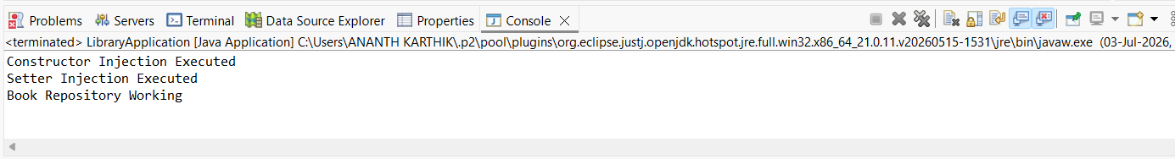

Exercise 8: Implementing Basic AOP with Spring
Given Scenario:
The library management application requires basic AOP functionality to separate cross-cutting concerns like logging and transaction management.
Solution:
BookRepository.java
package com.library.repository;
public class BookRepository {
public void saveBook() {
System.out.println("Book saved successfully");
}
}

BookService.java
package com.library.service;
import com.library.repository.BookRepository;
public class BookService {
private BookRepository bookRepository;
public void setBookRepository(BookRepository bookRepository) {
this.bookRepository = bookRepository;
}
public void addBook() {
bookRepository.saveBook();
System.out.println("Book Service Executed");
}
}

LoggingAspect.java
package com.library.aspect;
public class LoggingAspect {
public void beforeMethod() {
System.out.println("Before Method Execution");
}
public void afterMethod() {
System.out.println("After Method Execution");
}
}

applicationContext.xml
<?xml version="1.0" encoding="UTF-8"?>
<beans xmlns="http://www.springframework.org/schema/beans"
xmlns:xsi="http://www.w3.org/2001/XMLSchema-instance"
xmlns:aop="http://www.springframework.org/schema/aop"
xsi:schemaLocation="
http://www.springframework.org/schema/beans
https://www.springframework.org/schema/beans/spring-beans.xsd
http://www.springframework.org/schema/aop
https://www.springframework.org/schema/aop/spring-aop.xsd">
<!-- Repository Bean -->
<bean id="bookRepository"
class="com.library.repository.BookRepository"/>
<!-- Service Bean -->
<bean id="bookService"
class="com.library.service.BookService">
<property name="bookRepository" ref="bookRepository"/>
</bean>
<!-- Aspect Bean -->
<bean id="loggingAspect"
class="com.library.aspect.LoggingAspect"/>
<!-- AOP Configuration -->
<aop:config>
<aop:aspect ref="loggingAspect">
<aop:pointcut id="serviceMethods"
expression="execution(* com.library.service.*.*(..))"/>
<aop:before
pointcut-ref="serviceMethods"
method="beforeMethod"/>
<aop:after
pointcut-ref="serviceMethods"
method="afterMethod"/>
</aop:aspect>
</aop:config>
</beans>

LibraryManagementApplication.java
package com.library;
import org.springframework.context.ApplicationContext;
import org.springframework.context.support.ClassPathXmlApplicationContext;
import com.library.service.BookService;
public class LibraryManagementApplication {
public static void main(String[] args) {
ApplicationContext context =
new ClassPathXmlApplicationContext("applicationContext.xml");
BookService bookService =
(BookService) context.getBean("bookService");
bookService.addBook();
}
}

pom.xml
<dependencies>
<dependency>
<groupId>org.springframework</groupId>
<artifactId>spring-context</artifactId>
<version>5.3.30</version>
</dependency>
<dependency>
<groupId>org.springframework</groupId>
<artifactId>spring-aop</artifactId>
<version>5.3.30</version>
</dependency>
<dependency>
<groupId>org.aspectj</groupId>
<artifactId>aspectjweaver</artifactId>
<version>1.9.21</version>
</dependency>
</dependencies>

Output:
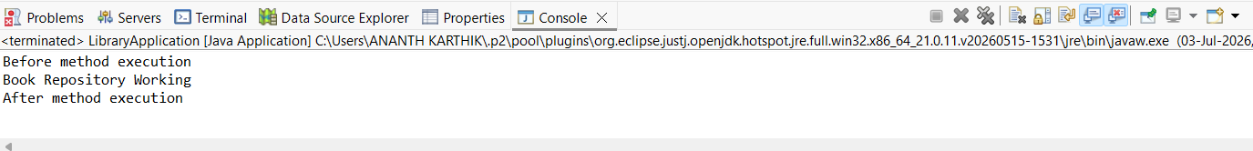

Exercise 9: Creating a Spring Boot Application
Given Scenario:
You need to create a Spring Boot application for the library management system to simplify configuration and deployment.
Solution:
application.properties
spring.datasource.url=jdbc:h2:mem:librarydb
spring.datasource.driverClassName=org.h2.Driver
spring.datasource.username=sa
spring.datasource.password=
spring.jpa.hibernate.ddl-auto=update
spring.jpa.show-sql=true
spring.h2.console.enabled=true
spring.h2.console.path=/h2-console

Book.java
package com.library.entity;
import jakarta.persistence.Entity;
import jakarta.persistence.GeneratedValue;
import jakarta.persistence.GenerationType;
import jakarta.persistence.Id;
@Entity
public class Book {
@Id
@GeneratedValue(strategy = GenerationType.IDENTITY)
private Long id;
private String title;
private String author;
public Book() {
}
public Book(String title, String author) {
this.title = title;
this.author = author;
}
public Long getId() {
return id;
}
public void setId(Long id) {
this.id = id;
}
public String getTitle() {
return title;
}
public void setTitle(String title) {
this.title = title;
}
public String getAuthor() {
return author;
}
public void setAuthor(String author) {
this.author = author;
}
}

BookRepository.java
package com.library.repository;
import org.springframework.data.jpa.repository.JpaRepository;
import org.springframework.stereotype.Repository;
import com.library.entity.Book;
@Repository
public interface BookRepository extends JpaRepository<Book, Long> {
}

BookController.java
package com.library.controller;
import java.util.List;
import org.springframework.beans.factory.annotation.Autowired;
import org.springframework.web.bind.annotation.*;
import com.library.entity.Book;
import com.library.repository.BookRepository;
@RestController
@RequestMapping("/books")
public class BookController {
@Autowired
private BookRepository repository;
@PostMapping
public Book addBook(@RequestBody Book book) {
return repository.save(book);
}
@GetMapping
public List<Book> getAllBooks() {
return repository.findAll();
}
@GetMapping("/{id}")
public Book getBookById(@PathVariable Long id) {
return repository.findById(id).orElse(null);
}
@PutMapping("/{id}")
public Book updateBook(@PathVariable Long id,
@RequestBody Book book) {
Book existingBook = repository.findById(id).orElse(null);
if (existingBook != null) {
existingBook.setTitle(book.getTitle());
existingBook.setAuthor(book.getAuthor());
return repository.save(existingBook);
}
return null;
}
@DeleteMapping("/{id}")
public String deleteBook(@PathVariable Long id) {
repository.deleteById(id);
return "Book Deleted Successfully";
}
}

LibraryManagementApplication.java
package com.library;
import org.springframework.boot.SpringApplication;
import org.springframework.boot.autoconfigure.SpringBootApplication;
@SpringBootApplication
public class LibraryManagementApplication {
public static void main(String[] args) {
SpringApplication.run(
LibraryManagementApplication.class, args);
}
}

pom.xml
<dependencies>
<dependency>
<groupId>org.springframework.boot</groupId>
<artifactId>spring-boot-starter-web</artifactId>
</dependency>
<dependency>
<groupId>org.springframework.boot</groupId>
<artifactId>spring-boot-starter-data-jpa</artifactId>
</dependency>
<dependency>
<groupId>com.h2database</groupId>
<artifactId>h2</artifactId>
<scope>runtime</scope>
</dependency>
</dependencies>

Output:
